Title (Times New Roman, bold, 11 pt)
O. Chirkov^{a1}, L. Nazarenko^{b} (Times New Roman, Bold, 10 pt)
ªG.S. Pysarenko Institute of Problems of Strength, the National Academy of Sciences of Ukraine, Kyiv, Ukraine.
^{b}Otto von Guericke University, Magdeburg, Germany
¹ email@gmail.com

Keywords: elastic-plastic model, strain gradient, Drucker's postulate, boundary value problem, variational formulation. (Times New Roman, 9 pt)

The main text should be typed in Times New Roman, 10 pt, width aligned, the indentation of the first line of all paragraphs, starting from the first one, is 0.75 cm.
Formulas should be typed using the Microsoft Word formula editor.
$$S\left(e,T\right)=\left\{\begin{matrix} 3G_{0}\left(T\right) \left(e-q\right), e≤e_{p}; \\ f \left(e,T\right), e>e_{p},\end{matrix}\right.$$ | (1)

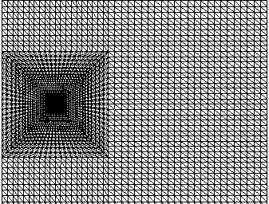 | 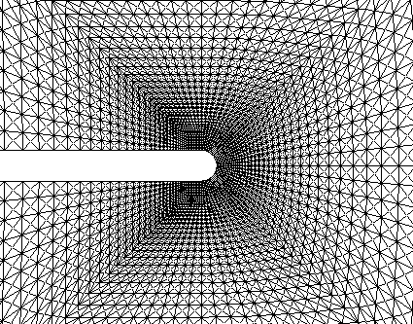
a | b
Fig. 1. Fragments of a triangular grid: a - uniform and transitional grid with thickening to the cutout end; b - mesh in the vicinity of the cutout end.

Figures must be in JPG, JPEG, PNG formats with a resolution of at least 600dpi. Figures prepared in the Microsoft Word text editor are not allowed. The caption under the figure is 9 pt, before and after the figure there is one space, letters indicating several figures are Italic 10pt.

Table 1. (Times New Roman 9 pt)
Table title (Times New Roman 9 pt, centered, bold)
Material | E, GPa | σ* | H_{IT}, GPa | σ* | HV, MPa | σ* | H/E | σ* | H³/E², MPa | σ*
NiAl | 144,70 | 1,31 | 3,67 | 0,07 | 339 | 6,16 | 0,025 | 0,0007 | 0,0024 | 0,0002
References to sources in the bibliography (TimesNewRoman, 10pt) should be indicated in the text in square brackets (for example, [2, 5 – 7]). Examples of the references of the main types of sources are given below.

- Z.S. Basinski, The instability of plastic flow of metalls at very low temperatures, ProcRoySoc, A-240, 229-242 (1957).
- J. S. Stolken & A. G. Evans, “A microbend test method for measuring the plasticity length scale”, Acta Mater, 46, 5109–5115 (1998).
- Y. Chirkov, L. Nazarenko, H. Altenbach, “Mixed FEM implementation of three-point bending of the beam with an edge crack within strain gradient elasticity theory”, Continuum Mech Thermodyn. 37(1) (2025)
- B. Ma., H. Zhao, D.u et al., Study on material design and corrosion resistance based on multi-principal component alloying, Theory Materials, 16(5), 1939 (2023) https:// doi.org/10.3390/ma16051939

