Title (Times New Roman, bold, 11 pt)
O. Chirkov^{a1}, L. Nazarenko^{b} (Times New Roman, Bold, 10 pt)
ªG.S. Pysarenko Institute of Problems of Strength, the National Academy of Sciences of Ukraine, Kyiv, Ukraine.
^{b}Otto von Guericke University, Magdeburg, Germany
¹email@gmail.com (Times New Roman, 9 pt)

We consider a simplified elastic-plastic model with a small strain gradient that includes a dimensional dependence associated with the microstructure of an isotropic material. It is assumed that elastic deformations and their gradients are described by the equations of the gradient theory of elasticity within the simplified model. Additionally, the equations of plastic flow are determined using a dissipative function expressed in terms of plastic strain rates and their corresponding gradients. According to the adopted equations, the elastic-plastic model is enriched with elastic and plastic strain gradients, which extends the modeling capabilities by including the dimensional scales of the material's internal length associated with elasticity and plasticity-driven dissipation. (Times New Roman Italic font, 9 pt. The volume of annotation is from 10 to 15 lines)

Keywords: elastic-plastic model, strain gradient, Drucker's postulate, boundary value problem, variational formulation.

The main text should be typed in Times New Roman, 10 pt, width aligned, the indentation of the first line of all paragraphs, starting from the first one, is 0.75 cm.
The text should consist of sections. The first section should be Introduction, the last Conclusions, all others should indicate the structural parts of the publication. Section titles should be typed in Times New Roman, 10 pt, Bold, 12 pt top indent, 6 pt bottom indent. For all sections except Introduction and Conclusions, serial numbers should be indicated.
Formulas should be typed using the Microsoft Word formula editor.
$$S\left(e,T\right)=\left\{\begin{matrix} 3G_{0}\left(T\right) \left(e-q\right), e≤e_{p}; \\ f \left(e,T\right), e>e_{p},\end{matrix}\right.$$ | (1)

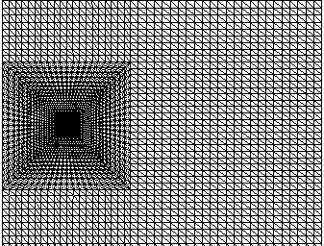 | 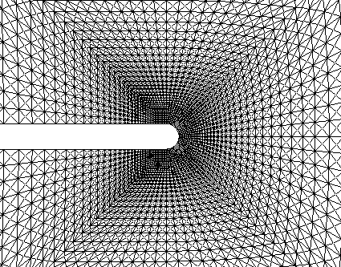
a | b
Fig. 1. Fragments of a triangular grid: a - uniform and transitional grid with thickening to the cutout end; b - mesh in the vicinity of the cutout end.
Figures must be in JPG, JPEG, PNG formats with a resolution of at least 600dpi. Figures prepared in the Microsoft Word text editor are not allowed. The caption under the figure is 9 pt, before and after the figure there is one space, letters indicating several figures are Italic 10pt.

Table 1. (Times New Roman 9 pt)
Table title (Times New Roman 9 pt, centered, bold)
Material | E, GPa | σ* | H_{IT}, GPa | σ* | HV, MPa | σ* | H/E | σ* | H³/E², MPa | σ*
NiAl | 144,70 | 1,31 | 3,67 | 0,07 | 339 | 6,16 | 0,025 | 0,0007 | 0,0024 | 0,0002
NiTi | 62,35 | 4,53 | 2,54 | 0,17 | 235 | 15,43 | 0,041 | 0,0021 | 0,0044 | 0,0006

References to sources in the bibliography (TimesNewRoman, 10pt) should be indicated in the text in square brackets (for example, [2, 5 – 7]). Examples of the references of the main types of sources are given below.

- Z.S. Basinski, The instability of plastic flow of metalls at very low temperatures, ProcRoySoc, A-240, 229-242 (1957).
- J. S. Stolken & A. G. Evans, “A microbend test method for measuring the plasticity length scale”, Acta Mater, 46, 5109–5115 (1998).
- Y. Chirkov, L. Nazarenko, H. Altenbach, “Mixed FEM implementation of three-point bending of the beam with an edge crack within strain gradient elasticity theory”, Continuum Mech Thermodyn. 37(1) (2025)
- B. Ma., H. Zhao, D.u et al., Study on material design and corrosion resistance based on multi-principal component alloying, Theory Materials, 16(5), 1939 (2023) https:// doi.org/10.3390/ma16051939

